Kthan Graham

Design an algorithm that will read the same file as in Problem 4, and produce a weekly report of the net earnings for those employees. Net earnings are gross earnings minus deductions. Each employee has two deductions from their gross earnings each week: tax payable (15% of gross earnings) and medical levy (1% of gross earnings). Your report is to print the gross earnings, tax payable, medical levy and net earnings for each employee. At the end of the report, print the total gross earnings, total tax, total medical levy and total net earnings.

Defingin Diagram:

|  |  |  |
| --- | --- | --- |
| Input | Processing | Output |
| Payrate  Reghours  OT | GrossE=(Payrate*RegHours)+(Payrate*OT*1.5)  TaxPay=.15*GrossE  Medical=.01*GrossE  NetEarn=GrossE-Taxpay-Medical  TotalGross=TotalGross+GrossE  TotalTax=TotalTax+Taxpay  TotalMed=TotalMed+medical  TotalNet=Totalnet+netearn | GrossE  TaxPay  Medical  NetEarn  TotalGross  TotalTax  TotalMed  TotalNet |

Algorithm:

Payroll totals

GrossE=(Payrate*RegHours)+(Payrate*OT*1.5)

TaxPay=.15*GrossE

Medical=.01*GrossE

NetEarn=GrossE-Taxpay-Medical

End

Flowchart:

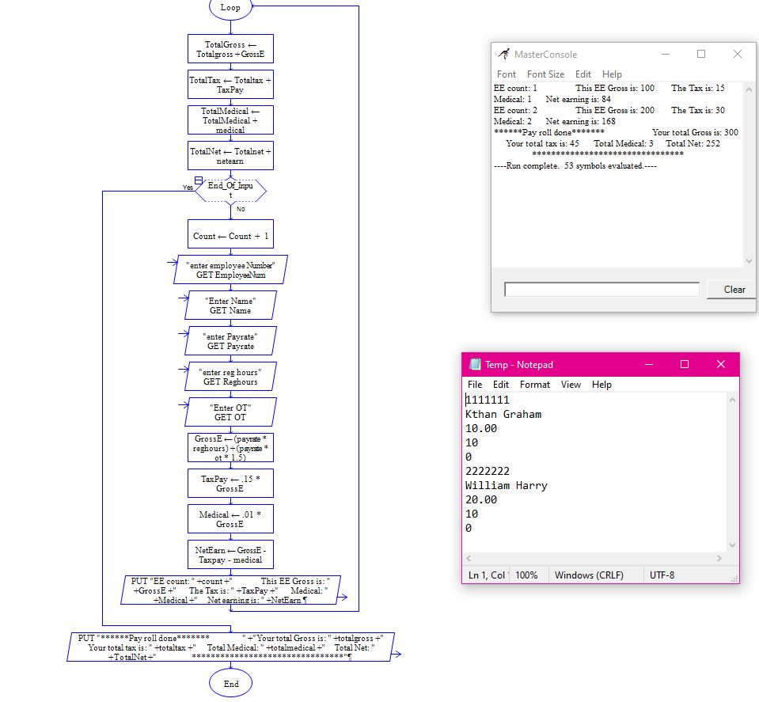

Desk check:

Hours worked: 10 payrate 10

GrossE=10*10=100

Tax=.15*100=15

Medical=.01*100=1

Net earn=100-15-1=84

Hours worked: 10 payrate 20

GrossE=10*20=200

Tax=.15*200=30

Medical=.01*200=2

Net earn=100-30-2=168

Totals=add up the end results

End.